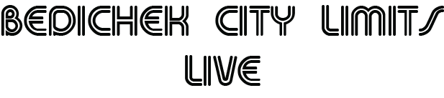
The Bedichek Fine Arts Team is proud to present Bedichek City Limits Live on November 19th, 2020.
Please join the Fine Arts team for a live-streamed event showcasing what your students have been learning and performing over the course of this virtual semester.
Bedichek City Limits Live will feature performances by the Bedichek Band, Dance, Theatre, Guitar, Mariachi, Choir, and live appearances from your students!
Please join us on November 19th, 2020 at 7pm for BCL Live. We look forward to seeing you there!

